Questionnaire
You can respond by completing the questionnaire which can be accessed via the link https://forms.gle/ScxN4V1iiy7uzxzS6
or complete and submit this form to MarketSupervisionPolicyDepartment@set.or.th
- General Information
Name-Surname
Company name |  | (Symbol | )
Position
Telephone number
E-mail address
Category of the respondent (You may choose more than one.)
Listed Company | Securities Firms / Financial Advisors
Legal Advisor | Individual Investor
Institutional Investor / Asset Management Companies | Other (Please specify) ..................................
- Request for Comment (If you agree but the details are otherwise, or disagree, please provide your reasons.)
Question 1: Enhancing the Role of Internal Auditors
1.1 Do you agree with establishing qualification requirements for the internal auditor (the person appointed to hold the highest responsibility for the internal audit function, or the lead supervisor of the engagement who signs the internal control audit report) of a new listing applicant on SET or mai, in line with the SEC's criteria?
Agree
Agree, but the details are otherwise. | (Please explain your reasoning)
Disagree | (Please explain your reasoning)
Other suggestions:
1.2 Do you agree with requiring the internal auditor of an existing listed company — covering Thai companies and foreign companies with shares that are, or will be, traded on the exchange, including Primary Listing, and Secondary Listing/Dual Listing from Unrecognized Countries) — to hold a certificate related to internal auditing, as prescribed by the SEC, while exempting the minimum work experience requirement until the internal auditor is changed?
Agree
Agree, but the details are otherwise. | (Please explain your reasoning)
Disagree | (Please explain your reasoning)
Other suggestions:

1.3 Do you agree with requiring listed companies to disclose any change of internal auditor (resignation or new appointment) within 3 business days from the date of the event?
Agree
Agree, but the details are otherwise. | (Please explain your reasoning)
Disagree | (Please explain your reasoning)
Other suggestions:

1.4 Do you agree with the proposal that, for new listing applicants on SET or mai, the criteria will take effect concurrently with the SEC's notification, expected from January 1, 2028?
Agree
Agree, but the details are otherwise. | (Please explain your reasoning)
Disagree | (Please explain your reasoning)
Other suggestions:

1.5 Do you agree with the proposal that, for existing listed companies, the criteria will take effect 1 year after the SEC's notification, expected from January 1, 2029?
Agree
Agree, but the details are otherwise. | (Please explain your reasoning)
Disagree | (Please explain your reasoning)
Other suggestions:

Question 2: Reviewing Measures for Non-Compliance
2.1 Do you agree with shortening the trading suspension (SP) period prior to delisting to 1 year in all cases?
Agree
Agree, but the details are otherwise. | (Please explain your reasoning)
Disagree | (Please explain your reasoning)
Other suggestions:
2.2 Do you agree with strengthening the measures for an insufficient number of independent directors (ID), using the same approach as for an insufficient number of AC members, in order to encourage listed companies to promptly nominate and appoint IDs in compliance with the criteria?
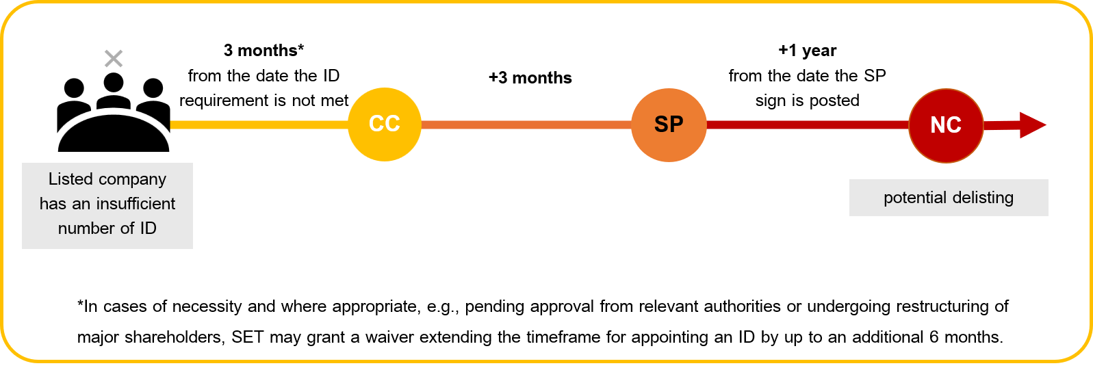
Agree
Agree, but the details are otherwise. | (Please explain your reasoning)
Disagree | (Please explain your reasoning)
Other suggestions:
Question 3: Enhancing Information Disclosure
3.1 Do you agree with requiring listed companies that fail to comply with the disclosure requirements to disclose the preventive measures they will implement to avoid a recurrence of such non-compliance, so that investors are informed accordingly?
Agree
Agree, but the details are otherwise. | (Please explain your reasoning)
Disagree | (Please explain your reasoning)
Other suggestions:
3.2 Do you agree with requiring listed companies to disclose, on an annual basis, the Annual Continued Listing Qualifications Assessment, certified by the board of directors and prepared in the format prescribed by SET, together with the relevant remedial measures, and non-submission within the specified period will result in enforcement measures: a CC sign for 3 months → SP sign for 1 year → Delisting?
Agree
Agree, but the details are otherwise. | (Please explain your reasoning)
Disagree | (Please explain your reasoning)
Other suggestions:
3.3 Do you agree with requiring the disclosure of the Annual Continued Listing Qualifications Assessment Form to take effect within the same due date as the submission of the 2026 One Report (to be submitted in early 2027)?
Agree
Agree, but the details are otherwise. | (Please explain your reasoning)
Disagree | (Please explain your reasoning)
Other suggestions:
Question 4: Empowering the Exercise of Shareholders' Rights at Shareholders' Meetings
4.1 Do you agree with requiring all listed companies to provide investors with the option to grant proxy electronically through the e-Proxy Voting System, a standardized, reliable, and transparent system?
Agree
Agree, but the details are otherwise. | (Please explain your reasoning)
Disagree | (Please explain your reasoning)
Other suggestions:
4.2 Do you agree with the proposal that all listed companies use electronic delivery of notices of shareholders' meetings and supporting documents via QR Code, as prescribed by TSD, as the primary method?
Agree
Agree, but the details are otherwise. | (Please explain your reasoning)
Disagree | (Please explain your reasoning)
Other suggestions:
Question 5: Extending the Principles under Sections 1–4 to Other Types of Listed Securities
SET proposed to apply the revised principles under Sections 1–4 above to revise the criteria for other types of listed securities, only to the extent appropriate to the nature of operations of each security type.
5.1 Do you agree with shortening SP period — from 2 years to 1 year prior to delisting for violations, non-compliance with the rules, or failure to disclose material information — to trusts, property funds and infrastructure funds (“trusts and funds”)?
Agree
Agree, but the details are otherwise. | (Please explain your reasoning)
Disagree | (Please explain your reasoning)
Other suggestions:
5.2 Do you agree with applying the requirement to disclose preventive measures — where an issuer fails to comply with the disclosure requirements, to prevent a recurrence — to all types of listed securities, such as trusts and funds, ETFs, derivative warrants (DWs), and depositary receipts (DRs)?
Agree
Agree, but the details are otherwise. | (Please explain your reasoning)
Disagree | (Please explain your reasoning)
Other suggestions:
5.3 Do you agree with applying the measures to promote shareholders' rights— including (1) providing securityholders with the option to grant proxy electronically through the e-Proxy Voting System, and (2) adopting electronic delivery of meeting documents via QR code, as prescribed by TSD, as the primary method — to all types of listed securities, such as trusts and funds, ETFs, DWs, and DRs?
Agree
Agree, but the details are otherwise. | (Please explain your reasoning)
Disagree | (Please explain your reasoning)
Other suggestions:
Other suggestions …………………………………………………………………………………………………………………………………………………………………………………………………………………………………………………………………………………………………………………………………………………………………………………………………………………………………………………………………………………………………………………………………………………………………………………………………………………………………………………
Please submit your comments and suggestions by August 7, 2026. SET will process your personal information for the purpose of Market Consultation, our policy on protection of personal data is set out in the Privacy Notice accessible via this link https://www.set.or.th/th/privacy-notice
SET would like to thank you for your comments and suggestions on this occasion.

