Questionnaire
You can respond by completing the questionnaire which can be accessed via the link https://forms.gle/Kiun5QRsvrNojRdMA or complete and submit this form to MarketSupervisionPolicyDepartment@set.or.th
- General Information
Name-Surname
Company name |  | (Symbol | )
Position
Telephone number
E-mail address
Category of the respondent (You may choose more than one.)
Listed Company | Securities Firms / Financial Advisors
Legal Advisor | Individual Investor
Institutional Investor / Asset Management Companies | Other (Please specify)..................................
- Request for Comment (If you agree but the details are otherwise, or disagree, please provide your reasons.)

Question 1: Disclosure of Shareholders' List
1.1 Do you agree with the requirement for disclosure of the updated shareholders’ list when there is a report of a change in shareholding of every 5% of total voting rights (Form 246) and a report of a Tender Offer results (Form 256), with monthly disclosure following such reports?
Agree
Agree, but the details are otherwise. | (Please explain your reasoning)
Disagree | (Please explain your reasoning)
Other suggestions:

1.2 Do you agree with the 'Notice Pending' (NP) designation when a company fails to disclose its shareholders’ list as required?
Agree
Agree, but the details are otherwise. | (Please explain your reasoning)
Disagree | (Please explain your reasoning)
Other suggestions:

1.3 Do you agree with the requirement for Thai NVDR Company Limited (NVDR) to disclose the list of holders simultaneously with the listed company in all cases?
Agree
Agree, but the details are otherwise. | (Please explain your reasoning)
Disagree | (Please explain your reasoning)
Other suggestions:

Question 2: Disclosure of Transactions Posing Risks to Financial Position and Operating Results
Do you agree with enhancing timely disclosure requirements when a listed company or its subsidiary has transactions that may affect the financial position and operating results, as follows:
  - Upon recoding of asset impairment, provisions for expected credit losses or similar asset-related items, or failure to recover deposits by the due date, where amounts are material, defined as: exceeding 50% of the specific transaction value, exceeding 50% of operating revenues, or causing a company to report a loss.
Agree
Agree, but the details are otherwise. | (Please explain your reasoning)
Disagree | (Please explain your reasoning)
Other suggestions:

  - Upon determination by the listed company or its audit committee that significant events or indicators exist that may adversely impact internal control systems, including but not limited to a notification from the external auditor concerning internal controls deficiencies.
Agree
Agree, but the details are otherwise. | (Please explain your reasoning)
Disagree | (Please explain your reasoning)
Other suggestions:

Question 3: Revision of Backdoor Listing Rules
Overview of the Backdoor Listing Rules (Proposed Revisions Indicated in Blue)
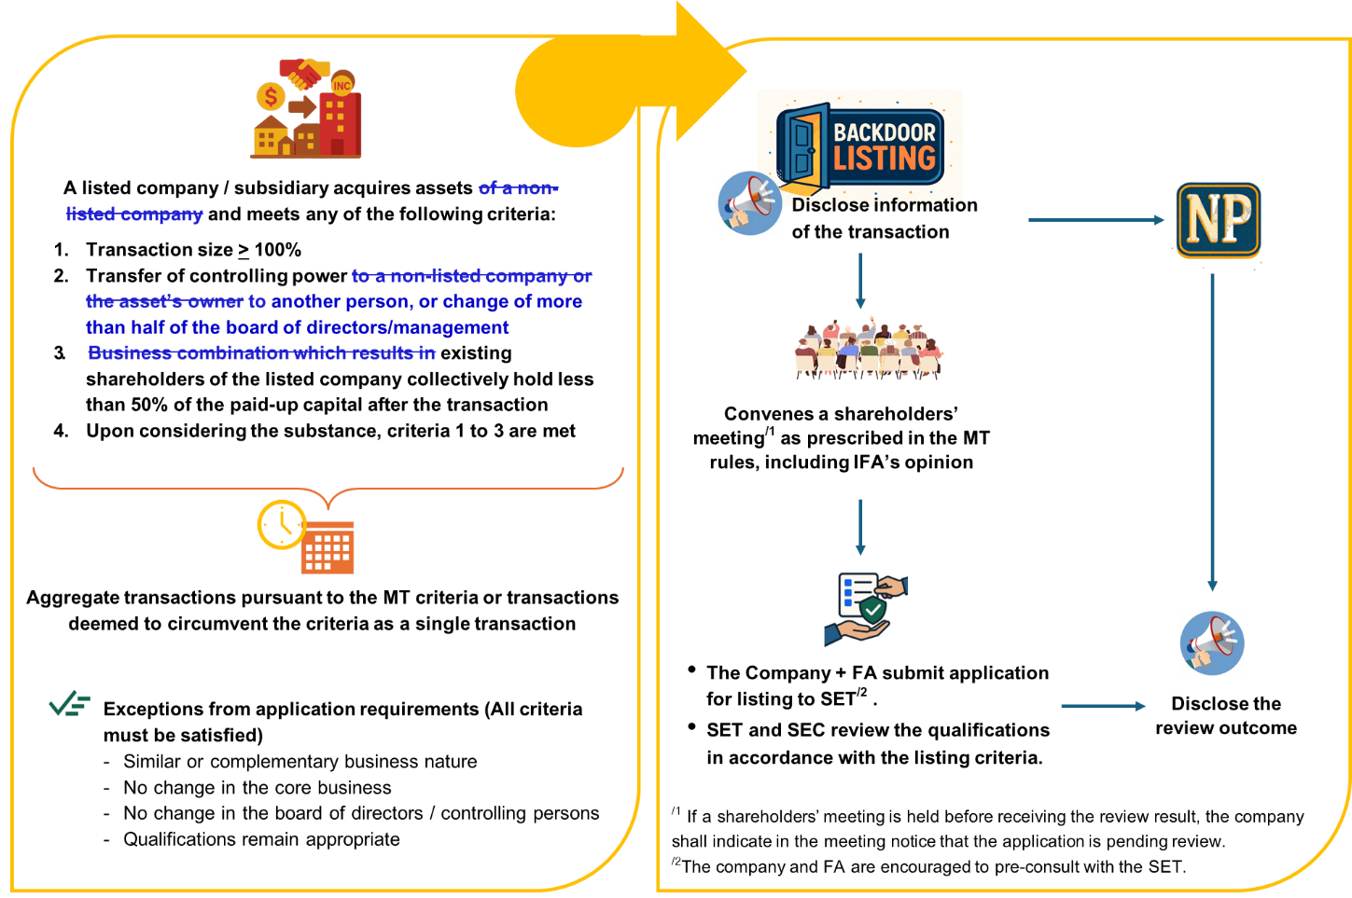
3.1 Do you agree with the revision to the criteria for determination Backdoor Listing, by removing the limitation to the acquisition of assets from a non-listed company?
Agree
Agree, but the details are otherwise. | (Please explain your reasoning)
Disagree | (Please explain your reasoning)
Other suggestions:

3.2 Do you agree with classifying a transaction as a Backdoor Listing when it involves the acquisition of assets that results in a change in control from the controlling persons of the listed company to another party, or when there is a change of more than half of the board of directors/management?
Agree
Agree, but the details are otherwise. | (Please explain your reasoning)
Disagree | (Please explain your reasoning)
Other suggestions:

3.3 Do you agree with classifying a transaction as a Backdoor Listing when it involves the acquisition of assets that results in existing shareholders holding less than 50% of the company's paid-up capital after the transaction, regardless of the transaction structure?
Agree
Agree, but the details are otherwise. | (Please explain your reasoning)
Disagree | (Please explain your reasoning)
Other suggestions:

Question 4: Revision of Cash Company Criteria
Overview of the Cash Company Criteria (Proposed Revisions Indicated in Blue)
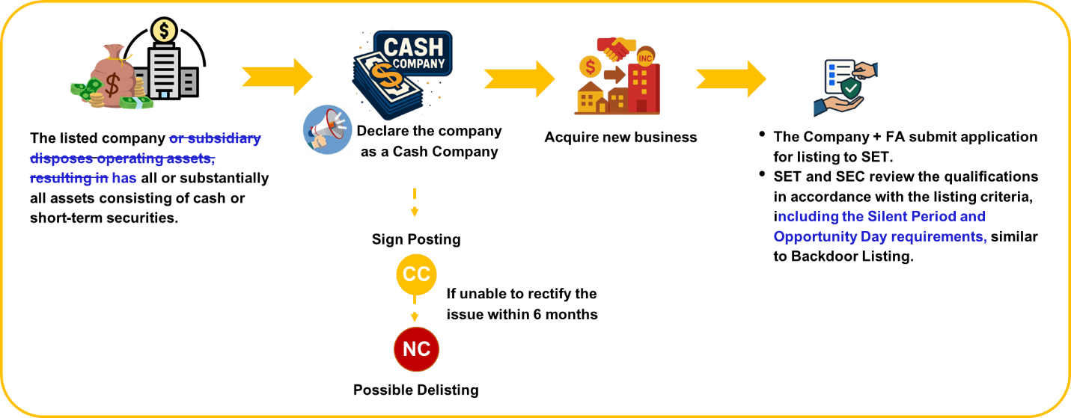
4.1 Do you agree with classifying a company as a 'Cash Company' based on its overall asset structure, without limiting the definition to cases where assets have been disposed?
Agree
Agree, but the details are otherwise. | (Please explain your reasoning)
Disagree | (Please explain your reasoning)
Other suggestions:

4.2 Do you agree with the requirement for a Cash Company to comply with the Silent Period and Opportunity Day requirements, similar to Backdoor Listing companies?
Agree
Agree, but the details are otherwise. | (Please explain your reasoning)
Disagree | (Please explain your reasoning)
Other suggestions:

Question 5: Investor Warning Sign (C Signs) Requirements
Do you agree with reviewing the criteria for warning sign designation (i.e. CC, CF) by changing the timeframe calculation from the date of information disclosure to the date the listed company is obligated to disclose such information, thereby preventing listed companies from benefiting from delayed disclosure?
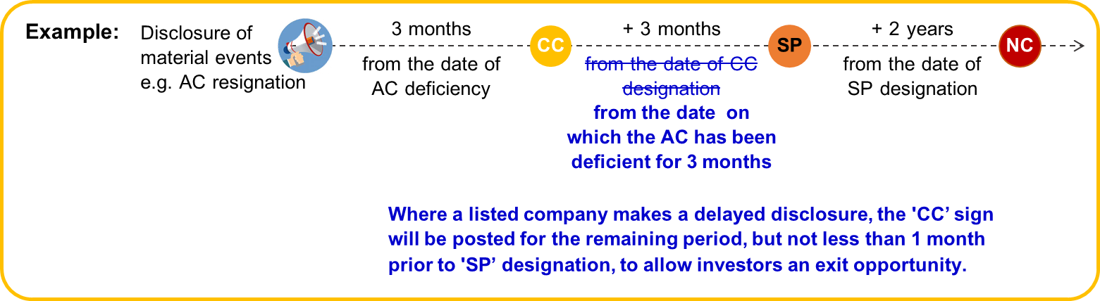

Agree
Agree, but the details are otherwise. | (Please explain your reasoning)
Disagree | (Please explain your reasoning)
Other suggestions:

Question 6: Review of Disclosure Requirements and Related Matters
6.1 Do you agree with abolishing duplicative requirements that overlap with the SEC regulations to prevent confusion for practitioners and reduce compliance redundancy e.g., provisions concerning MT and RPT?
Agree
Agree, but the details are otherwise. | (Please explain your reasoning)
Disagree | (Please explain your reasoning)
Other suggestions:

6.2 Do you agree with removing disclosure obligations regarding the launch of new products, as this constitutes the company's ordinary course of business?
Agree
Agree, but the details are otherwise. | (Please explain your reasoning)
Disagree | (Please explain your reasoning)
Other suggestions:

6.3 Do you agree with mandating immediate disclosure of amendments to the memorandum of association or articles of association of listed companies, with a submission of a copy to the SET within 14 days of such amendments, in alignment with the Public Limited Companies Act?
Agree
Agree, but the details are otherwise. | (Please explain your reasoning)
Disagree | (Please explain your reasoning)
Other suggestions:

6.4 Do you agree with mandating immediate disclosure of bankruptcy filings against listed companies?
Agree
Agree, but the details are otherwise. | (Please explain your reasoning)
Disagree | (Please explain your reasoning)
Other suggestions:

6.5 Do you agree with aligning the reporting deadline for utilization of capital increase proceeds with the reporting schedule for shareholder-approved transaction updates as specified in the MT and RPT provisions, to reduce compliance burdens on practitioners?
Agree
Agree, but the details are otherwise. | (Please explain your reasoning)
Disagree | (Please explain your reasoning)
Other suggestions:

Question 7: Review of the disclosure criteria for Real Estate Investment Trusts (REITs), Property Funds, and Infrastructure Funds (collectively referred to as 'Trusts/Funds')
7.1 Do you agree with introducing disclosure requirements upon recognition of asset impairment, provisions for expected credit losses or similar asset-related items, or failure to recover deposits by the due date, where amounts are material, defined as: exceeding 50% of the specific transaction value, exceeding 50% of operating revenues, or causing Trusts/Funds to report a loss?
Agree
Agree, but the details are otherwise. | (Please explain your reasoning)
Disagree | (Please explain your reasoning)
Other suggestions:

7.2 Do you agree with imposing the 'Notice Pending' (NP) designation when Trusts/Funds fails to disclose the list of holders as required?
Agree
Agree, but the details are otherwise. | (Please explain your reasoning)
Disagree | (Please explain your reasoning)
Other suggestions:

7.3 Do you agree with mandating immediate disclosure of any event and subsequent progress when a Fund files for business rehabilitation or is subject to bankruptcy proceedings?
Agree
Agree, but the details are otherwise. | (Please explain your reasoning)
Disagree | (Please explain your reasoning)
Other suggestions:

7.4 Do you agree with abolishing disclosure obligations regarding the launch of new products and the acquisition or disposition of commercial agreements?
Agree
Agree, but the details are otherwise. | (Please explain your reasoning)
Disagree | (Please explain your reasoning)
Other suggestions:

7.5 Do you agree with abolishing the requirement to submit property appraisal reports to reduce redundancy with the SEC provisions?
Agree
Agree, but the details are otherwise. | (Please explain your reasoning)
Disagree | (Please explain your reasoning)
Other suggestions:

Other suggestions …………………………………………………………………………………………………………………………………………………………………………………………………………………………………………………………………………………………………………………………………………………………………………………………………………………………………………………………………………………………………………………………………………………………………………………………………………………………………………………
Please submit your comments and suggestions by November 14, 2025. SET will process your personal information for the purpose of Market Consultation, our policy on protection of personal data is set out in the Privacy Notice accessible via this link https://www.set.or.th/th/privacy-notice
SET would like to thank you for your comments and suggestions on this occasion.

